Civics Group | Index Number | Name (use BLOCK LETTERS)  H2

ST. ANDREW’S JUNIOR COLLEGE
2021 JC2 PRELIMINARY EXAMINATION


H2 BIOLOGY 9744/04

Paper 4: Practical Exam (Mark Scheme)

Tuesday 24th August 2021 2 hours 30 minutes

READ THESE INSTRUCTIONS FIRST

Write your name, civics group and index number on all the work you hand in.
Give details of the practical shift and laboratory, where appropriate, in the boxes provided.
Write in dark blue or black pen.
You may use a HB pencil for any diagram, graph or rough working.
Do not use staples, paper clips, highlighters, glue or correction fluid.

Answer all questions in in the spaces provided on the Question paper.

The use of an approved scientific calculator is expected, where appropriate. You may lose marks if you do not show your working or if you do not use appropriate units.

The number of marks is given in brackets [ ] at the end of each question or part question.

IMPORTANT INFORMATION TO CANDIDATES:

Candidates with access to microscope at the start of the paper are given the first 1h 15 min to use them. Please answer QUESTION 2 within this time frame. Once you have finished working with the microscope, you can move on to QUESTION 1.

Candidates with no access to microscope at the start of the paper should proceed with QUESTION 1 first. You will be given access to microscope at 1h 15 min after the start of the paper.

Shift
Laboratory

 | For Examiner’s Use
 | 1 | / 29
 | 2 | / 26
 | Total | / 55

This document consists of X printed pages.
[Turn over
Answer all questions

QUESTION 1

You are provided with a solution, labelled E, containing an enzyme Rennin which coagulates (clots) milk. Enzyme E hydrolyses (breaks) peptide bonds between certain amino acids in a protein found in milk and this results in the coagulation of the milk. Calcium ions are required for this coagulation.

When a mixture of milk, calcium chloride solution and E is gently rotated in a test-tube the
coagulation goes through the stages shown in Fig. 1.1.

Stage 3 is the end-point of the enzyme-catalysed coagulation.

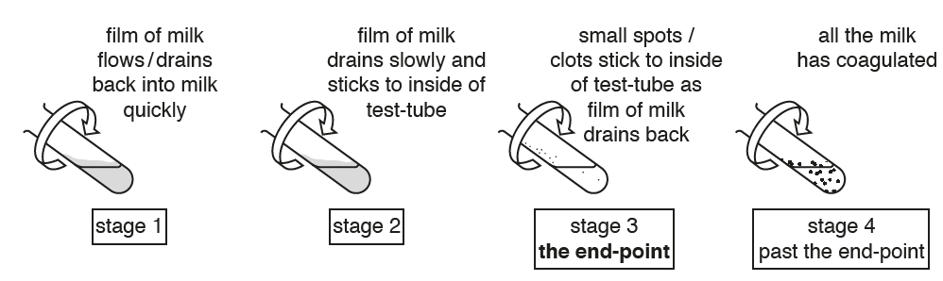
Fig. 1.1

You are required to:
- perform a simple dilution of milk solution M1
- investigate the action of E on the different concentrations of milk solution
- record the time taken to reach the end-point for each concentration of milk solution
- determine the concentration of milk in sample solution X
You are provided with:

- 10% calcium chloride solution C, in a plastic container labelled C
- 0.25% enzyme Rennin solution E, in a plastic container labelled E
- Milk solution M1, in a plastic container labelled M1
- Sample solution X, in a plastic container labelled X
- Distilled water, in a plastic container labelled DW

Solution C and E are irritants. If C or E comes into contact with your skin, wash it off immediately under tap water. Suitable eye protection should be worn.

You are required to investigate the effect of substrate concentration on this enzyme-catalysed coagulation.

(a)
(i) You are required to prepare different concentrations of milk, using M1 and DW. M1 is undiluted milk and is referred to as 100.0% milk solution.

Simple dilutions of M1 is to be carried out to obtain three other concentrations M2, M3 and M4, in which the concentration of milk solution is reduced by 25.0 % between each successive dilution. You will need to prepare 20.0 cm³ for each concentration.

Complete Table 1.1 to show how you will prepare the different concentrations of milk solution.
…….……………………………………………………………………………..………[2]

Table 1.1

Concentration of Milk  solution / % | Volume of M1  / cm³ | Volume of DW  / cm³
100.0 | 20.0 | 0.0

Concentration of Milk  solution / % | Volume of M1  / cm³ | Volume of DW  / cm³
100.0 | 20.0 | 0.0
75.0 | 15.0 | 5.0
50.0 | 10.0 | 10.0
25.0 | 5.0 | 15.0

(ii) Describe a hypothesis for the expected relationship between the rate of enzyme-catalysed coagulation and milk concentration. Assume that all other conditions are kept constant.
………………………………………………………………………………………………[1]

- The rate of enzyme-catalysed coagulation should increase (linearly, then increase at a decreasing rate) as milk concentration increases ;
and will eventually reach a maximum / plateau ;
Before proceeding further:
- Use the beaker labelled Hot water to collect approximately 200cm³ of hot water from where it is provided in the laboratory.
- Use the beaker labelled Tap water to collect approximately 200cm³ of tap water from the tap.
Proceed as follows:
- Prepare the concentrations of milk as written in Table 1.1, using the small plastic containers provided.
- Use the hot and tap water to set up a water-bath in a 500ml beaker. The starting temperature of the water-bath should be between 35°C and 40°C.
You will not need to maintain this temperature from this point onwards.
- Put 5.0 cm³ of the M1 into a test-tube. Label the test-tube as 100%.
- Repeat step 3 with each of the other concentrations of milk that you have prepared and label them accordingly. Also do this for sample solution X.
- Put 0.5 cm³ of C into each test-tube.
- Gently shake each of the test-tubes to mix the milk solution and C.
- Put the test-tubes in the water-bath and leave for at least 3 minutes.
(iii) Explain why the test-tubes are left in the water-bath for at least 3 minutes in step 7.
…………………………………………………………………………………………………………………[1]

- Refer to equilibrating the contents (M1 and C) of the test-tubes, to reach the temperature of the water-bath ;

- Remove the test-tube containing X from the water-bath.
The process of coagulation will start when E is added.
- Put 0.5 cm³ of E into the test-tube, so that it runs down the side of the test-tube and forms a layer on the surface of the mixture, as shown in Fig. 1.2.
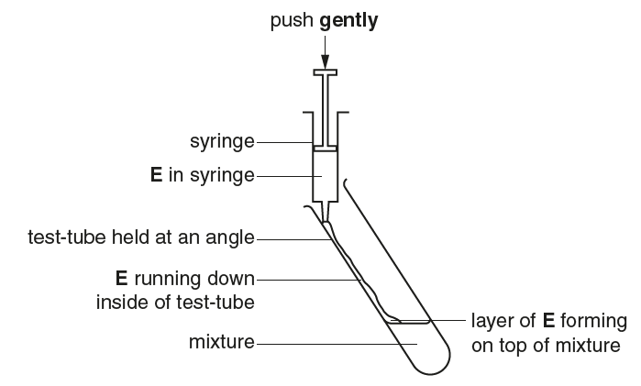

Fig. 1.2

- Gently shake the test-tube to mix the solutions and start timing.
- Hold the test-tube over a piece of black card on the table as shown in Fig. 1.3.
- Gently rotate the test-tube to form a film of milk on the inside of the test-tube.

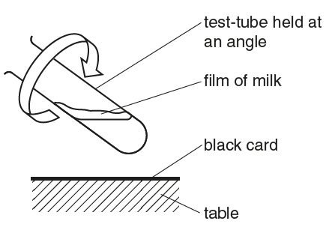
Fig. 1.3

- Observe the film and stop timing once the end-point is reached (stage 3 in Fig. 1.1). Ignore any small bubbles on the inside of the test-tube.
- Record the time taken to reach the end-point for sample X in (a)(iv).
If the end-point has not been reached in 4 minutes, stop timing and record the time taken as ‘more than 240’.
(iv) State the result for sample X.
....................................... s [1]
- Time in whole numbers
[Acceptable value should be higher than student’s value for 100% milk in data table but not “more than 240s”; Tch e.g.= 46s]

- Repeat step 8 to step 14 with the other test-tubes labelled 100% and each of three other concentrations of milk that you have prepared in the water-bath.
Also calculate the relative rate of enzyme-catalysed coagulation and record your results for 100% and each of three other concentrations of milk that you have prepared (excluding sample X) in (a)(v).
If the time recorded is ‘more than 240’, state the relative rate of coagulation as ‘zero’.
(v) Record your results in an appropriate format in the space provided.
…………………………………………………………………………………………[4]

Table showing effects of different milk concentration on the time taken to reach endpoint, to calculate the rate of enzyme-catalysed coagulation

Milk Concentration  / % | Time taken to reach endpoint  / s | (Relative) Rate of coagulation  x 10⁻² / s⁻¹ | OR | (Relative) Rate of coagulation  x 10⁻² / s⁻¹
100.0 | 30 (20, 20, 23) | 3 |  | 3.3
75.0 | 40 (40 , 35, 37) | 3 |  | 2.5
50.0 | 50 (50, 50, 45) | 2 |  | 2.0
25.0 | 120 (100, 103, 105) | 1 |  | 0.8

[Accept: standard form in the rows only if different 10^{-x}]

- Independent variable: presented on leftmost column with appropriate heading and unit
Reject: “Concentration” (too vague)

- Measured variable / Calculated variable (Dependent variable): separate columns with appropriate headings and units
Reject: “Time taken”, “relative rate” (too vague)

- Precision of data:
- Time taken to reach endpoint: In seconds (Accept whole no. only),
AND
- (Relative) Rate of coagulation:
- MUST be in standard form (Accept: whole no. or 1.dp),
- If time taken is stated as ‘more than 240’, only accept the rate as ‘zero’. Reject ‘0’.

Note that the mathematical notation for a number written in standard form is, a x 10^{n} where n is an integer (whole number) and 1 ≤ a < 10

- Data recorded for all 4 concentrations + correct Trend (ref to “time taken to reach end point”): Shorter time taken for higher milk concentration.

(vi) Complete Fig. 1.4:
- using labels to show the positions of the three other percentage concentrations of milk solution, that you have prepared by simple dilution.

- using an arrow and label of the letter X to show an estimate of the concentration of milk in the sample X, by comparing your results recorded in (a)(iv) and (a)(v).
0%
100%

Percentage concentration of milk

Fig 1.4
…………………………………………………………………………………………[2]

X

0%
100%
75%
50%
25%

Percentage concentration of milk

- Appropriate labels for 25%, 50% and 75% (equidistant)
- Accept arrow + label “X” on scale
[Based on student’s result for sample X in (a)(iv)]
REJECT: If arrow is beyond the range of scale (>100%, or <0%)

(vii) Replicating or repeating the investigation would increase the confidence in your estimate of the milk concentration in sample X.

Describe two other modifications to this method to obtain a more accurate estimate of the concentration of milk in the sample solution X.
…………………………………………………………………………………………[2]
ANY TWO:
Similar points, accept only (1) or (2) as one point, not both
- Use a greater range of values for concentration of milk standards. E.g. Include more concentrations below 25% (range of 0-100% instead of 25-100%);
[REJECT: if student’s answer is above 25% estimation]
- Use greater number of values for concentration of milk standards. E.g. 10 concentrations instead of only 4;
- draw graph / best-fit line using data points to better quantify the estimate for sample concentration (after performing replicates) ;
[REJECT: Use a colorimeter / spectrophotometer to estimate the milk concentration more accurately using absorbance value; as curdled milk and non-curdled milk are same color intensity, all white]
- [Improved method] Measuring mass of curd using a weighing balance, after a fixed duration (e.g. 5 min) using a stopwatch ;
- OVP ;

[REJECT:
- perform a control, which does not help in more accurate estimation
- Replicates or repeats which are stated in Q]

(viii) One significant source of error for this investigation is the fluctuation in temperature of the manual water bath after step 2.

Complete Table 1.2 to suggest:
- How to make an improvement in reducing the fluctuation in temperature of the manual water bath after step 2.
- one other significant source of error in this procedure
- how to make an improvement to reduce this other source of error.

Table 1.2
………………………….………..………………………..………………………………..[3]

Significant source of error | How to make an improvement
1. Temperature fluctuations occurred in the water bath after step 2. [Given] | Use a thermostatically controlled water bath set at a specific temperature, e.g. 37^{O}C (accept between 35 ^{O}C to 40 ^{O}C)  OR  Use a manual water bath / continue to maintain temperature of water bath at a specific temperature, e.g. 35 ^{O}C after step 2 using hot water and tap water, measured using a thermometer.
ANY ONE:
2. Difficulty in deciding when the end-point is reached.  [REJECT: Use a colorimeter / spectrophotometer to estimate the milk concentration more accurately using absorbance value; as curdled milk and non-curdled milk are same color intensity, all white] | Use video to record the progress of the experiment and review judgement of time to reach end point ;  OR  Carrying out a trial test prior to the experiment (to familiarise with the endpoint) ;  OR  Ref. take a photo of the 4 different stages as reference to identify the endpoint better ;  REJECT: Measuring mass of curd after fixed timing or other new methods.
3. Lack of equilibration of enzyme E (only equilibration of milk and C was done) | Equilibrate 0.5cm³ of E in a separate test-tube in the same water bath (between 35^{O}C to 40^{O}C) for 3 mins
5. pH fluctuations may occur as it was not kept constant | Adding 1 cm³ (specify a fixed volume) of a pH buffer, to each set-up.  REJECT: Use “pH logger / meter”. [This device helps to measure pH only.]
6. OVP

(ix) Describe a suitable control for this experiment to show that Rennin (in solution E) is an enzyme that catalyses the coagulation reaction.

Note: You do not need to carry out this control.
…………………………………………………………………………………………[1]

- replaces enzyme solution / E with equal volume/ 0.5cm³ of boiled and cooled enzyme solution ;
and keep all other experimental conditions the same ;

- In a different experiment, a student carried out an investigation into the effect of temperature on the activity of the enzymes in Yeast cells.

The student immobilised the yeast cells in alginate beads which were then dropped into glucose solution at different temperatures. As carbon dioxide collected in the beads they rose to the surface of the solution as shown in Fig. 1.5.

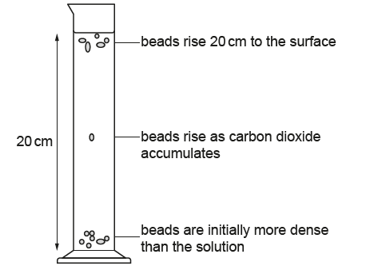

Fig. 1.5

The student measured the time taken for 5 beads to rise to the surface, a distance of 20 cm.

(i) Two variables in this investigation that were standardised were:
- The number of yeast-alginate beads used (at five per setup)
- The volume of glucose solution used to obtain a height of 20 cm

Describe how two other variables in this investigation could be standardised.
………………………………………………………………………………………………[2]

- Concentration of glucose solution: Using the same (stock) concentration e.g. 1% of glucose solution ;
- Concentration of yeast solution to prepare the alginate beads: Using the same (stock) concentration e.g. 10% of yeast solution ;
/ Volume of yeast solution to be kept constant at 5.0 cm³ using a (5.0 cm³) syringe.
- Proportion of alginate to yeast in preparing yeast-alginate solution: Ref. example of ratio ;
- Mass of beads: Use beads of same mass e.g. 0.5 g each + measured using a weighing balance ;
OR
Size of beads: Use beads of equal diameter e.g. 5mm each + measured using a ruler;
- OVP

The processed results are shown in Table 1.3.

Table 1.3

temperature / °C | mean time taken for last bead to rise to the surface / s
10.0 | 72
25.0 | 19
40.0 | 11
55.0 | 36
70.0 | 108
(ii) Identify the temperature at which the beads rose the fastest: ………………..^{O}C

For this temperature, calculate the absolute rate at which these beads rose 20 cm.

Show your working.

- Correct temp = 40.0^{O}C [ACCEPT: whole number or 1 dp]

- Correct calculation of rate + in 1.dp + correct units [no ECF]
[Reject: relative rate as absolute rate is possible and more accurate]

Rate = distance / time
= 20 cm / 11s
= 1.8 cm s⁻¹ (1.d.p) [Accept: whole number, 2 cm s⁻¹]

Rate = ……………………….
[2]

(iii) Use the grid provided to display the results shown in Table 1.3.

………………………………………………………………………………………………[4]

Graph of temperature against mean time taken for last bead to rise to the surface

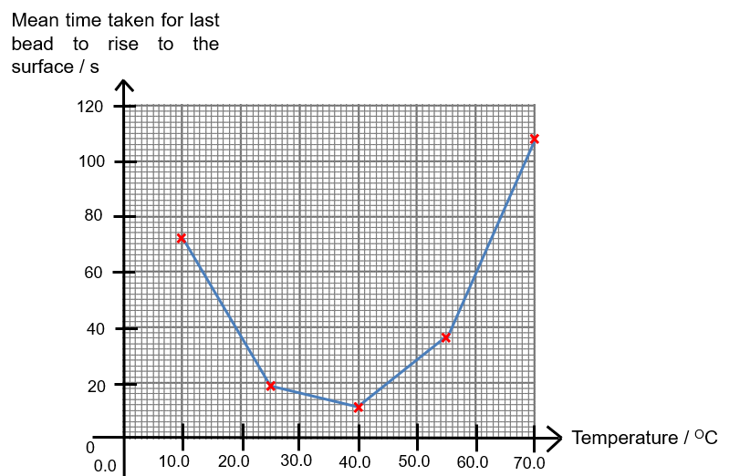

Title of graph provided ;

- Axes: Independent variable (temperature) with correct d.p (1.d.p) on x-axis and dependent variable (Mean time taken for last bead to rise to the surface) on y-axis; + both axes correctly labelled with units;
- Scale: Appropriate scale with graph occupying at least 2/3 the grid on both x- and y- axes + equidistant divisions on axes ;
- Points: Accurate plotting of all points to nearest half a small square;
- Line: point-to-point ruled line drawn, without extrapolation beyond plotted points;
[Accept: best-fit / smooth curve (as trend is known from theory & replicates were done (“mean”), but still recommended to do point-to-point plot.]

(iv) Describe and explain the shape of the graph between 40.0^{O}C and 70.0^{O}C.
………………………………………………………………………………………………[4]

[Describe + Quote] - COMPULSORY
- As temperature increases from 40.0^{O}C and 70.0^{O}C, the mean time taken for the beads to rise to the surface increases sharply from 11s to 108s ; [Accept: splitting of section into 2 sections]

[Explain] – ANY THREE
- At temperatures higher than optimum temperature of the yeast enzyme, rise in kinetic energy of results in more thermal agitation ;
- This disrupts the hydrogen bonds, ionic bonds and hydrophobic interactions (at least 2 e.g. ignore: disulfide bonds) between the {R-groups / amino acids} (in enzyme) ;
- This results in the denaturation of the enzyme ;
Loss of 3D conformation of enzyme’s active site / substrate is no longer able to bind to enzyme’s active site ;
- Thus resulting in a lower frequency of effective collisions between enzyme and substrate; fewer enzyme-substrate complexes formed per unit time / fewer products formed per unit time (thus, the slower rate of rising of bead) ;

[Total: 29]

QUESTION 2

For this question, you will require access to a light microscope (with an eyepiece graticule) and the plastic container labelled M, which contains a stage micrometer.

You are provided with a leaf L, in a petri dish labelled L.

Stoma (singular) / Stomata (plural) is a structure on the surface of a leaf that modulates gas exchange between the plant and its environment. Most stomata are found on the lower surface of the leaf.
Each stoma is made of two guard cells. When these guard cells are turgid, they create an opening between them, called the stomatal pore. Gas exchange (CO₂, O₂) occurs via this pore, which is crucial for the process of photosynthesis.
In this investigation, you will indirectly view the stomata of a provided leaf specimen L under the microscope.

Proceed as follows:

- Place the leaf specimen L on a white tile, with the lower surface of the leaf facing upwards.
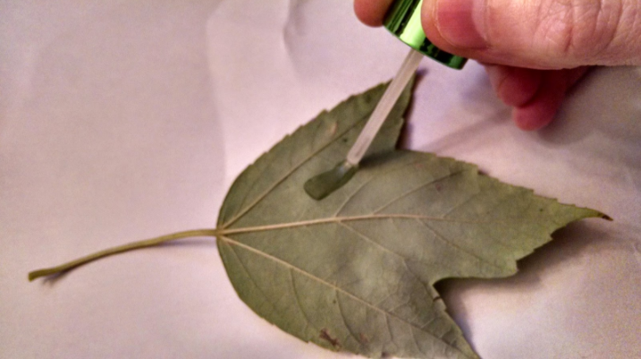
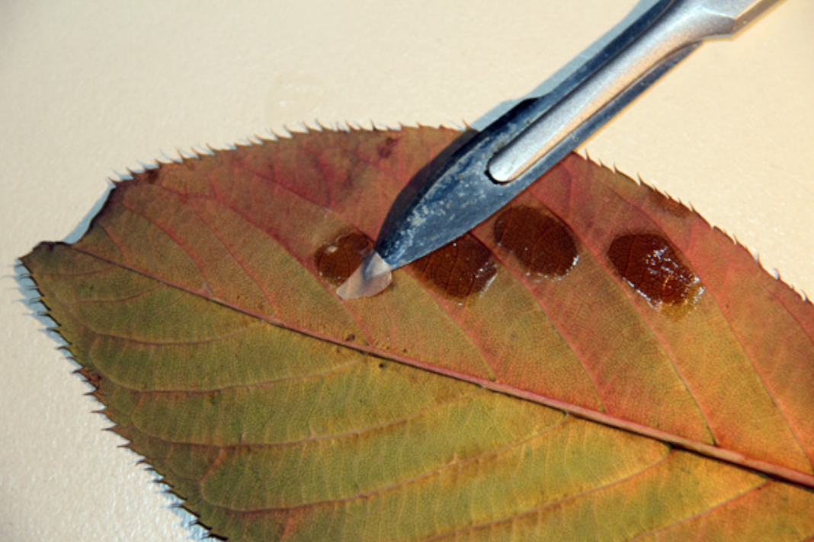
- Cover a small area (about 1 cm²) of the specimen with a thin layer of clear nail varnish. Do not cover an area with large veins.
Ref. Step 2
Ref. Step 3

Source: Photos obtained from http://phdnthesinglemom.blogspot.com/2014/10/epidermal-leaf-slides.html & http://www.microbehunter.com/using-clear-nail-polish-to-make-impressions-of-plant-leaves/
- Repeat step 2 three more times on different areas of the specimen to ensure that you have sufficient spare material if necessary.
- Put the specimen aside for at least 20 minutes, for the nail varnish to completely dry.
- During this waiting period, work through parts 2(b), 2(c) and/or 2(d), or go on to other parts of the Question paper, as appropriate.
- After the nail varnish has dried, carefully use the blade of a fine scalpel to lift one edge of the layer of nail varnish. You may then use forceps to gently peel the layer of nail varnish from the specimen. The layer is still useful even if it does not come off in one piece.
- Transfer the layer to a clean microscope slide. Gently place a cover slip on the thin layer. No water is required.

- Examine the slide using a microscope and locate an area with stomata. Then observe the stomata under high power objective lens.

Make a large drawing of one stoma with well-defined features. Surrounding epidermal cells are not to be included.

Label the stomatal pore and a guard cell.

…..…...…………………………..…………………………………………………………[3]

High power drawing of a stoma (x400 magnification)

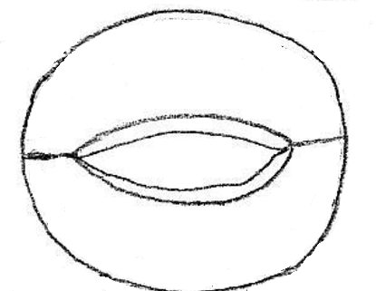
Stomatal pore
Guard cell
OR
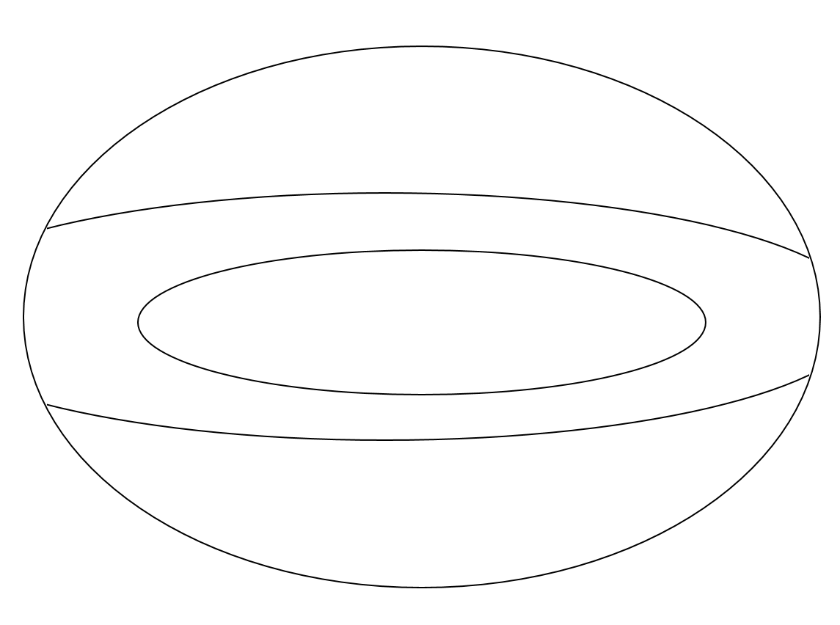
Stomatal pore
Guard cell

Title: Appropriate title & overall magnification stated; [Reject: Type of lens used e.g. 40x.];

- [S/Q] Size: Size of drawing is sufficiently large (at least 1/2 of space provided) ;
Quality: Cells drawn with clear, continuous lines + No shading ;
[Penalise: If arrow for length measurement – working for (a)(v), is drawn in the picture directly]
- [S] Shape: 2 adjoining bean shaped guard cells; (Ignore cell wall drawn)
[REJECT: if any organelles are drawn]
- [L] Labels: 2 appropriate labels: for stomatal pore + for 1 guard cell ;

- Did you observe the presence of chloroplasts in the guard cells when viewing the specimen under the microscope? Explain the reason for your answer.
……………………………………………………………………………………..……..[1]

- No chloroplast observed ;
This is an only an imprint of the leaf (surface), using the nail polish / specimen does not contain any actual cells ;

You are required to measure the actual length of stoma that you have drawn in (a)(i) on the slide, under high power objective lens.

Before measuring the length of the stoma, calibration of the eyepiece graticule needs to be conducted, under 40x objective lens.

It is given that the length of each stage micrometer division is 0.01 mm.

- Conduct the actual calibration for your eyepiece graticule under 40x objective lens.

Find the actual length of one eyepiece graticule unit.

Show all your workings clearly.
5 :20 = 1:4

Actual length of 1 eyepiece graticule unit: ..………..…… μm [1]

(Length of 1 stage micrometer unit = 0.01mm)
(Ratio = 1 stage micrometer division : 4 eyepiece graticule unit)

Length of 1 eyepiece graticule unit = 0.01mm x 1/4 = 2.5 μm

- Using the information found in (a)(iii), calculate the actual length of the entire stoma in your slide, under 40x objective lens.

Show all your workings clearly.
Actual length of entire stoma: ……………… μm [2]

Measurement under 40x objective lens:
- Length of entire stoma = 9 epu [Acceptable range: 5 – 20]
(Note: different specimens may have varied sizes) [Reject: decimal place]

- Actual length of entire stoma = Number of epu x 2.5μm*
= 9 x 2.5μm = 22.5 μm

- Using the information found in (a)(iv), calculate the magnification of your drawing of the stoma in (a)(i).

Show all the steps in your working clearly.

Magnification: .........................X [2]

E.g. 5.3 cm

e.g. Length of stoma in drawing = 5.3 cm

- Application of correct formula used with values & units shown ; correct final answer (in 3.S.F or whole no.)

E.g Magnification = Size of drawing _
Actual size of specimen

= 5.3 cm / 27.5 μm
= 53000 μm / 27.5 μm
= 1927.2727x
= 1930x (3 s.f.)

- A student observed the lower epidermis of leaf of another plant species under high power objective lens of a microscope. The student did this for four different regions of the leaf. This is shown in Fig. 2.1.
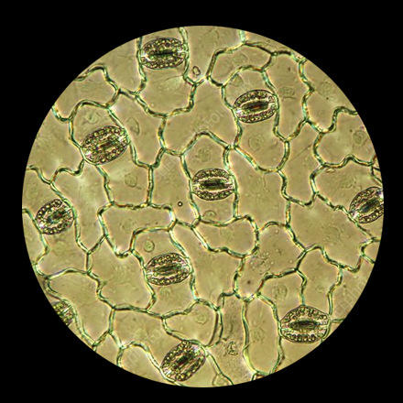  9 | 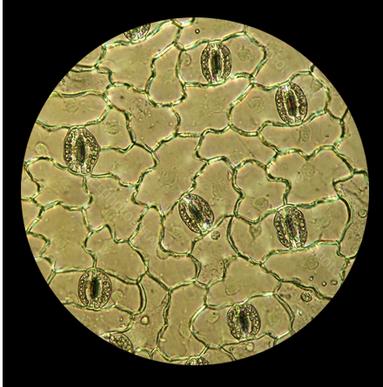  7
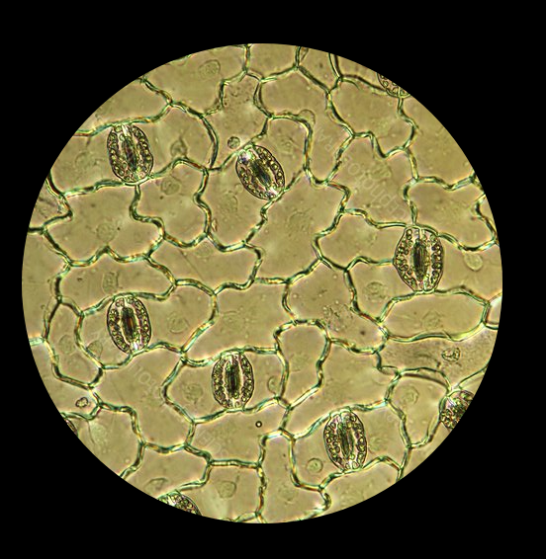  6 | 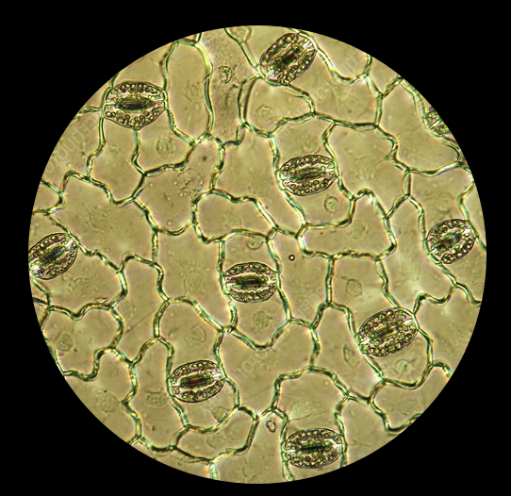  9
Fig. 2.1
Modified from: https://www.sciencephoto.com/media/594783/view/plantain-lily-stomata-light-micrograph

You will now determine the density of stomata on the lower surface of this leaf specimen.
- Count the number of stomata that is observed in each field of view as shown in Fig 2.1. Only include stoma for which the centre of its stomatal pore is fully visible.
Calculate the mean number of stomata per field of view.
Shown your workings.

Mean number of stomata in field of view = ……………………….. [2]
- Correct counting of stomata: 9 +7 + 6 + 9
- Correct average calculation to whole no.
31 / 4 = 7.75 = 8 (whole no.) [REJECT: 7.75]
(ii) Under the high power objective lens, the student used a stage micrometer and found out that the diameter of the field of view is 0.45 mm, as shown in Fig. 2.2.
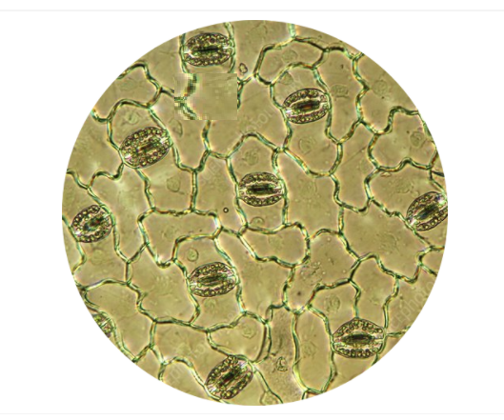
0.45 mm
Fig. 2.2

Calculate the area of the field of view and record this area in mm².
The area of a circle is given by the equation shown.

area of circle = 𝜋r²
where 𝜋 = 3.142 and r = radius of circle

Then use your result in (b)(i) to calculate the mean density of stomata per mm² for the student’s leaf specimen.

Show all your workings.
Mean density of stomata for leaf specimen = ………………………mm⁻² [2]
- Correct calculation of area of Field of View + accuracy of answer

Area of field of view
= 𝜋r²
= 3.142 x (0.45 mm / 2)²
= 0.15906
= 0.16 mm² (2.dp) OR 0.159 mm² (3.dp)

2. Correct calculation of stomata density + accuracy of answer:
Mean density of stomata for leaf specimen
= mean number of stomata per field of view / area of field of view
= 8 / 0.16 mm² OR 8 / 0.159 mm²
= 50.00 mm⁻² OR 50.314 mm⁻² (Accept: 2dp OR 3dp)

- Fig. 2.3 is a photomicrograph of a transverse section of a plant root under 80x magnification.

You are not expected to be familiar with this specimen.

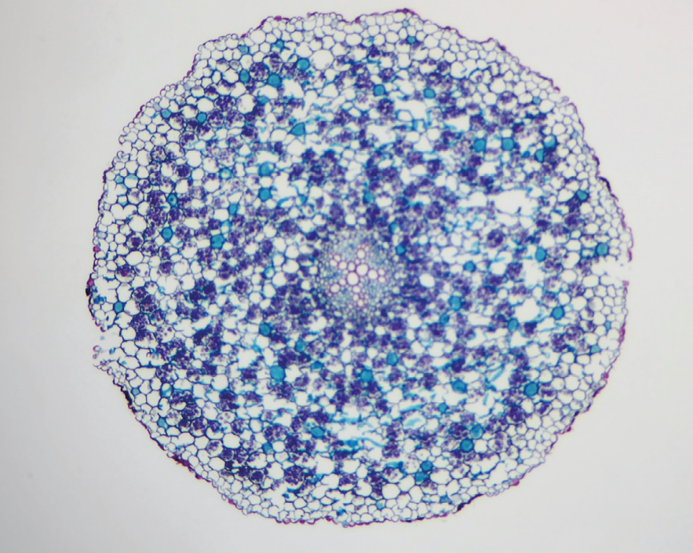
Fig. 2.3

- Draw a plan diagram of the plant root in Fig. 2.3.

A plan diagram shows the arrangement of the different tissues. Your drawing should show the correct shape and proportion of the tissues.

No cells should be drawn. No labels are required.
……………………………………………………………..………………..……..[4]

Plan drawing of transverse section of a root (x80 magnification)

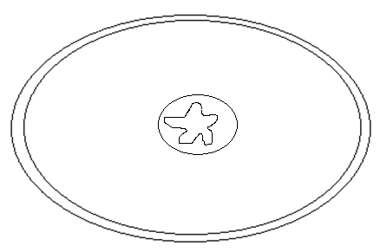

- [T/S] Title: Appropriate title & magnification stated; [REJECT: x800]
Size: Size of drawing is sufficiently large (at least 1/2 of space provided) ;

- [S] Shape: At least 4 lines (to depict 4 layers including vascular bundle) to mark outer epidermis (outermost layer), cortex (middle layer) and central vascular bundle + correct shape of vascular bundle (exactly 5 ‘arms’ / star shaped)

- [P] Proportion: Correct proportion where outer epidermis is thinner than the next inner layer in stem + vascular bundle is small

[REJECT: if size of vascular bundle is too large, I.E.>1/3 of drawing] (IGNORE: Structures in cortex layer)

- [Q] Quality: No individual cells drawn + no shading + no fuzzy and broken lines;

- Fig. 2.4 is a photomicrograph of a stained transverse section through a root of a different type of plant.

You are not expected to be familiar with this specimen.

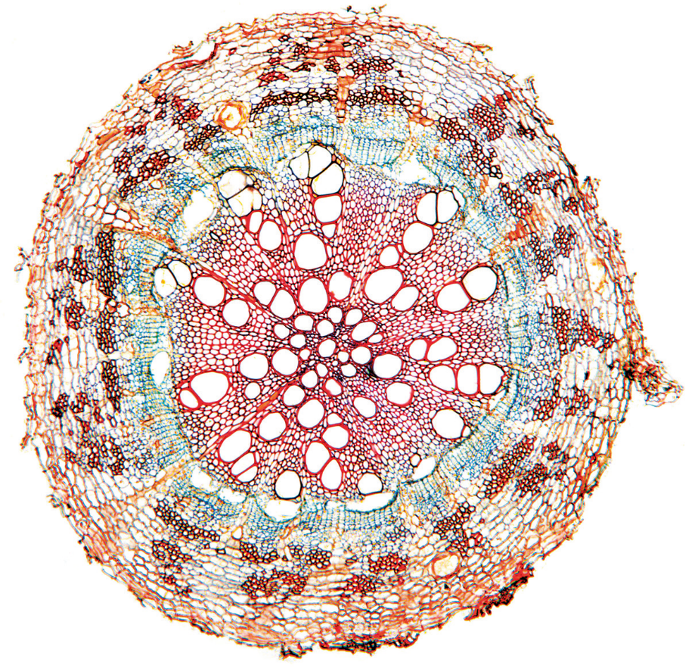
Fig. 2.4

Observe the root in Fig. 2.4 in comparison to that of Fig. 2.3.

Complete Table 2.1 to describe two observable differences between the two roots in Fig. 2.4 and Fig. 2.3 respectively.

No labels are required.

Table 2.1
…………………………….…………………………….…………………………….[2]

ANY TWO:
Difference | Fig. 2.4 | Fig. 2.3
1. Amount of vascular tissue | large(r) amount of vascular tissue / xylem / phloem tissues | small(er) amount of vascular tissue /xylem / phloem tissues
2. Size of cortex | small(er) cortex | large(r) cortex
3. number of layers | many / more | few / fewer
4. Shape of cortex / epidermis cells | rectangular / longer / flatter /  elongated cells | circular / round / oval
5. size of xylem cells  [Not to award if overlap with MP1] | Xylem cells / pore size is larger | Xylem cells / pore size is smaller
6. Epidermis layer | Epidermis surface is rougher | Epidermis surface is smoother
AVP

Invertase is an enzyme that catalysed the reaction, as shown in Fig. 2.5.
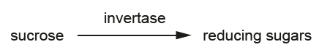
Fig. 2.5

You will plan and carry out an investigation to determine the concentration of sucrose in a sample of honey.

A student suggested the hypothesis that:

‘honey sample Z contains a sucrose concentration that is greater than 5%’.

The student carried out some preliminary experiments to find the optimum conditions for estimating the concentration of sucrose in a sample. ln the test, sucrose solution is mixed with invertase solution and, after a short incubation time, Benedict's solution is used to test a sample of the mixture for reducing sugar.

The time from starting the Benedict's test to the first colour change of Benedict's solution is recorded, up to a maximum of 180 seconds. This time provides an estimate of the concentration of sucrose. This is because the shorter the time, the higher the concentration of reducing sugar produced from the hydrolysis of sucrose by invertase. lf there is no colour change within 180 seconds of starting the Benedict's test, then it can be assumed that no reducing sugar is present.

The student found that:
- the best volumes of invertase solution and sucrose solution to use were those that gave a mixture in which sucrose solution accounted for 2/3 of the total mixture.
- hydrolysis of sucrose was most rapid at room temperature.
- the recommended incubation time for hydrolysis of sucrose in the presence of invertase was from two to five minutes.

Use the results of the preliminary tests to plan and carry out an investigation to provide results that will enable you to support or reject the student’s hypothesis.

You are provided with:
- only 10 cm³ of 5% sucrose solution, in a specimen tube labelled Y
- only 10 cm³ of a honey sample of unknown sucrose concentration, in a specimen tube labelled Z
- only 10 cm³ of 1% invertase solution, in a specimen tube labelled I.
- Benedict’s solution
For your planned method, it should:
- NOT involve the regulation of a fixed temperature using a water bath
- NOT involve the carrying out of replicates and/or repeats.
- have a clear and helpful structure so that the method described could be repeated by anyone reading it
- include details to ensure that results are as accurate and repeatable as possible
- use the correct technical and scientific terms
- only make use of the apparatus and materials provided.

You may use the space below to make any notes. Read through (d)(i), (d)(ii) and (d)(iii) before proceeding.

- Outline the steps in your method that you used to collect your results.
……………….………..…………………………………………………………..[3]
ANY TWO points = 1M, MAX 3M

Note: focus is only on the procedure as “question asks for the method”

I - Enzymatic Reaction Set-up:
- Add 2.0 cm³ of 5% sucrose solution / Y into a clean test-tube and add 1.0 cm³ of invertase solution / I to the same test-tube, using (different clean) syringe/s. Mix well ;
[Accept: Any ratio of Y:I = 2:1 + feasible volume] [Note: Max volume of test tube ~14cm³]
- Start timing using a stopwatch, for three minutes ;
[Accept: Any duration between (& including) 2 minutes to 5 minutes.]
- [Step to denature the enzyme to stop reaction] After three minutes, remove the test-tube and place it in a boiling water bath for 30 seconds ;

II - Benedict Test:
- Add equal volume / (for this example:) 3.0 cm³ of Benedict’s solution to the test tube using another syringe. Mix well ;
- Place the test tube in a boiling water bath;

III - Data Recording:
- Using a stopwatch, record the time taken for the initial colour change of the mixture to occur ; [REJECT: “for brick-red ppt to form (not Q focus)]
- If time exceeds 180s, record as “more than 180” ;

- Repeat for steps 1 to 7 for sample solution Z ;

IGNORE: Any mention about replicates or repeats, water bath or controls.

- Record your results in a suitable format in the space provided.
……………….………..…………………………………………………………..[3]

Table showing time taken for first colour change of Benedict’s solution /s from 5% sucrose solution Y and honey sample solution Z

Solution | Time taken for first colour change of Benedict’s solution / s
Y / 5% sucrose | 25 (18, 15, 16)
Z | 68 (30, 29, 26)

- [H] Heading of Independent variable: presented on leftmost column with appropriate heading; E.g. “sample” / “solution” [REJECT: sucrose concentration /%”]
+ Measured / Dependent variable: right column with appropriate headings and units ; “Time taken for first colour change of Benedict’s solution / s” ;

- [D] Data / Precision of data:
- Data recorded for both Y and Z.
- Raw data for “time”: In seconds (Accept whole no. only),
- Ignore: Calculating relative rate of hydrolysis of starch.

- [T] Trend: Y to take shorter time than Z .

NOTE: No marks if ONLY qualitative result (brick red PPT) is stated.

- State whether or not your results in (d)(ii) support the student’s hypothesis.

Give a reason for your answer.
……………….………..…………………………………………………………..[1]

(With reference to the student’ results stated in (d)(iii).)

- [Stand] My results does not support the student’s hypothesis ;
+
[Ref to data] The honey sample / Z took longer time of ____ for the benedict’s test than the 5% sucrose solution / Y which took ___;
(thus, Z has a sucrose concentration that is lower than 5%.)

[Total: 26]

~ END OF PAPER ~

